Steps:

1. Customer will fill the Enquiry Form and Submit it to the RE

|  |
| --- |
| Enquiry_Form_Details_Table |
| 1) Customer_Name  2) Customer_DoB  3) Customer_EmailId  4) Customer_MobNo  5) Customer_AdharCardNo  6) Customer_LocalAddress  7) Customer_PermanentAddress  8) Customer_MortgageDetails  9) Customer_LoanAmount_Required  10) Customer_Type |
|  |

2. RE log in to the web-app to create/view enquires:

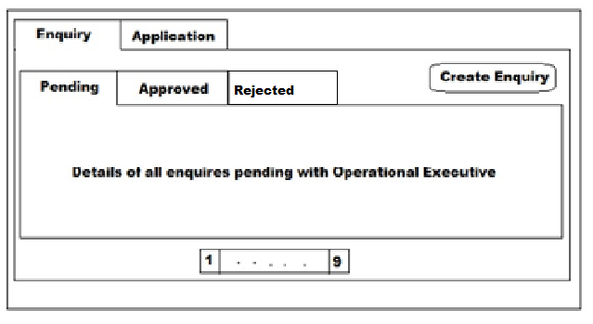

When RE login, then he is able to see this page.RE has a option of creating new Enquiry and can view the status pending/approved enquiries. On clicking Create Enquiry button a modal will pop up where RE will fill in all the details for creating enquiry. On clicking submit an entry will be added to enquiry_details table with status as “Pending with Operational Executive”.

3. OE log in to web-app to approve/reject enquires based on CIBIL score.

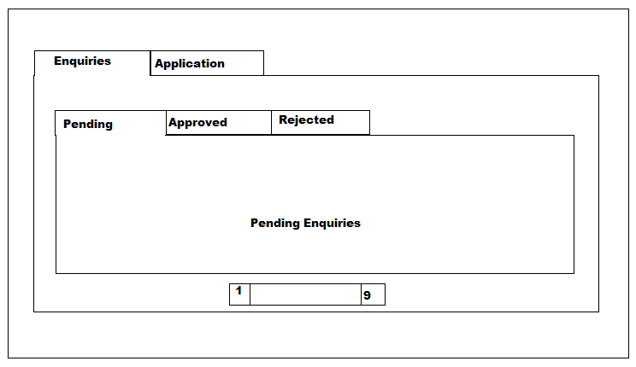

When OE login, then he will be able to see this page .On this screen he can see the new Enquiries and the Applications came. He will check it one by one and that customers CIBIL Score by using third party API and if it is valid then he will approved that particular enquiry, and if not valid then he will reject it other if some confusion or incomplete information then he will keep it pending. When he will click on Approved, Rejected and Pending button then RE can see this in his DB such as “Approved by Operational Executive”, “Rejected by Operational Executive” and “Pending with Operational Executive” respectively.

1. And then the approved enquiry customers are conveyed through this message of approval by RE.
2. Then the customer will apply for the loan

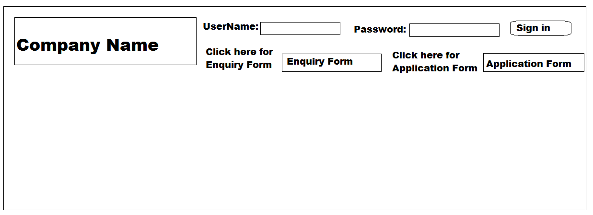

|  |
| --- |
| Application_Loan_Table |
| 1) Personal Details  2) Previous Loan Details  3) Bike Details  4) Loan Details  5) Document Details  6) Type of Customer  7) Guarantor Details |

|  |
| --- |
| Personal_Details_Table |
| 1) Customer_Name  2) Customer_DoB  3) Customer_EmailId  4) Customer_MobNo  5) Customer_AdharCardNo  6) Customer_LocalAddress  7) Customer_PermanentAddress  8) Customer_MortgageDetails  9) Customer_CIBILScore  10) Customer_Type |

|  |
| --- |
| Loan_Details_Table |
| 1) Loan_Amount  2) Insurance  3) Tenure |

|  |
| --- |
| PreviousLoan_Details_Table |
| 1) Loan_Id  2) Customer_Id  3) Loan_Amount  4) Tenure  5) Paid_Amount  6) Remaining_EMI |

|  |
| --- |
| Guarantor_Details_Table |
| 1) Guarantor_Name  2) Guarantor_DateofBirth  3) Guarantor_RelationshipwithCustomer  4) Guarantor_MobNo  5) Guarantor_AdharCardNo  6) Guarantor_MortgageDetails  7) Guarantor_JobDetails  8) Guarantor_LocalAddress  9) Guarantor_PermanentAddress |

|  |
| --- |
| Document_Details_Table |
| 1) Aggreement  2) Adhar_Card  3) PAN_Card  4) Photo(Image)  5) Qualification  6) Post_Dated_Check |

|  |
| --- |
| Bike_Details_Table |
| 1) Model  2) Price  3) Actual Price  4) On Road Price  5) Dealer |

|  |
| --- |
| Type_of_Customer_Table |
| 1) Business  2) Government_Job  3) Private_Job  4) Other |